

Capstone Project Phase B

Git link: https://github.com/MrLegiongame/GreenWave
GreenWave
25-1-D-22

Submiters: Leonid Vyushkov , Osher Ben Zazon
Project Manager: Ronen Zilber
Contents

- Project Review
  - Introduction - General Description ………….. 3
  - The Algorithm………………………………….. 4
  - Research process……………………………...10
  - Results…………………………………………..11
  - Conclusion………………………………………12

- User Documentation
  - User Guide………………………………………13
  - Operating Instructions………………………….17
  - Maintenance Guide……………………………. 24
    - User Guide
    - Maintenance Guide

Project Review

Introduction - General Description

During Phase A of the GreenWave project, we established the foundation for an interactive traffic simulation program written in Pygame. We created and implemented a multi‑screen GUI - with Main Menu, Settings, Simulation, and Statistics views - loaded arbitrary road‑network topologies from JSON, and crafted a combined Vehicle class to model private cars, buses, and trucks traveling along lanes and junctions. Phase A also added rudimentary turning logic, numeric‑only entry for vehicle quantities, and an extensible framework for rendering traffic flow.

In Phase B, we have built on this groundwork with two fundamental goals. The first is to develop and compare adaptive traffic‑light control algorithms, the GreenWave approach with fixed‑time and random schemes within our simulator. We've enhanced the vehicle model to include braking and realistic pollution/ energy consumption, and we permit users to parameterize maps, general vehicle stats, and algorithm selection. The program now includes a special Statistics window that displays visually‑engaging, side‑by‑side comparisons of each algorithm's performance, displaying important metrics such as average delay, throughput, and estimated energy savings on user topologies.

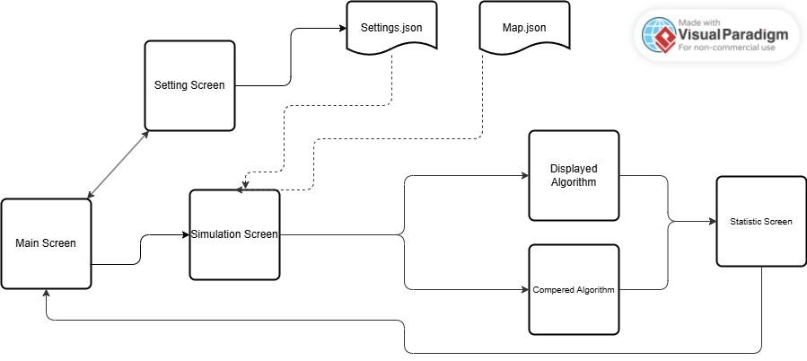
The goal is to examine our GreenWave algorithm compared to existing ones in terms of pollution and energy consumption; they will be enabled to try out simulation parameters and directly see their effect through the Statistics. By adjusting parameters interactively and viewing performance metric changes, users can rapidly test "what‑if" situations and hand‑tune control policies. Phase B therefore provides both sophisticated algorithmic comparison and an exploratory interface to impact analysis.

The Algorithm

The GreenWave control method is an adaptive method of controlling traffic signals with the intent of creating "green waves" along travel streams to minimize stops, delay, and energy usage. The GreenWave control method is distinctive by the fact that it does not utilize any foresight of future arrivals; at each cycle, the state is defined only from the queue length at the beginning of the cycle and instantaneous detection of vehicles.

Firstly, we want to present algorithms that we developed to create our simulation, which helps us to define if our algorithms are better than existing ones:

JSON → Map Import
Objective: Import a road‑network from JSON into the simulation’s in‑memory graph.
Input:
- json_data["Junctions"]: maps Junction IDs to directions, each with Index_in_map, Out_Lanes, In_Lanes.
- json_data["Roads"]: maps Road IDs to {direction1_index_in_map, direction2_index_in_map, length, max_speed}.
Process:
- Create Junctions & Directions
  - For each junction, create a Junction().
  - For each direction, create Direction(Index_in_map) and connect its OUT-lanes (Lane(OUT,…)).
- Link IN-Lanes
  - For each junction/direction, create Lane(IN, to_lanes=[…]) by looking up target OUT-lanes.
- Create Roads
  - – For each road entry, get the two Direction objects by index, and make Road(name, dir1, dir2, length, max_speed).
- Complete the Graph
  - – force_directed_layout(nodes, edges);
  - – seed vehicles;
  - – Make Graph(nodes, edges, vehicles, dt) and set each vehicle’s path.
Output:
A usable Graph object, ready for the simulation and control algorithms.

Create a graph to calculate the path
Objective: Create the graph to be used for vehicle path finding between it’s source out-lane and its destination in-lane
Input:
no input (self as Graph is given due to the method definition)
Process:
- Create an empty directed graph as G
- For each Junction, for each direction in the Junction, create an edge between every in-lane in that direction and each of it’s to-lanes, set weight to 0
- For each road, create an edge between every out-lane and it’s possible in-lane destinations (modeling lane switching in a graph), set the weight to the road length
Output:
A directed graph designed for vehicle path finding

Traffic lights creation
Objective: For each direction, the algorithm creates all the necessary traffic lights in a Junction
Input:
no input (self as Junction is given due to the method definition)
Process:
- For each direction in the Junction, going through it’s in-lanes from right to left (looking into the Junction), finding the next traffic light:
  - Remember the set of directions the current in-lane directs to, and the current in-lane itself in a set. Move to the next in-lane
  - If out of next in-lanes in direction: create a TrafficLight based on the set of in-lanes, clear memory, move to the next direction and repeat step a
  - Check whether there’s at least one common direction between the set of directions currently saved and the set of directions the current in-lane directs to:
    - If there are, update the set of directions currently saved to include the set of directions the current in-lane directs to, and update the set of in-lanes to include the current one, move to the next in-lane, and repeat step b
    - If there isn’t, create a TrafficLight based on the set of in-lanes, clear memory and repeat step a, without moving to the next in-lane
- Save all the traffic lights found as a set and return it
Output:
A set of all the traffic lights necessary in the Junction

Set the traffic lights’ states
Objective: For each traffic light, the algorithm computes a set of traffic lights with the maximum in-lanes amount that can operate simultaneously at a junction without causing conflicts (called states)
Input:
no input (self as Junction is given due to the method definition)
Process:
- Get all the traffic lights in the Junction
- For each traffic light, we use a custom knapsack-based algorithm to determine the state to which the traffic light belongs:
  - Set the current traffic light as included in the knapsack already
  - Run the knapsack algorithm using the following definitions:
    - The number of in-lanes belonging to the traffic light determines the REWARD
    - The WEIGHT is determined by the number of in-lanes blocked by the current traffic light and not by the current knapsack
- Create a tuple out of all the states and return it
Output:
A tuple of all the combinations described in the objective

Real-world traffic light algorithms:
Fixed‑Timing Cycle
Overview: A non‑adaptive baseline that cycles through all allowed phase combinations in strict order.
Selection Rule:
next = (current + 1) % states_size
Timing: There are five visual states (green, green-flickering, yellow, red, red+yellow) that are held for 2-3 s as instructed by update_state() and it takes 10 s to finish all the transitions. Because the time each step remains the same for every step, it allows for predictability but cannot ultimately respond to the increased activities of traffic situations.

Adaptive (Max‑Vehicle‑Count)
Objective: Dynamically prioritize the traffic light direction with the most vehicles in the queue.
Selection Rule:At each decision point, the algorithm assesses all of the possible phases by calculating and then selects the phase s that has the greatest QueueSize(s).
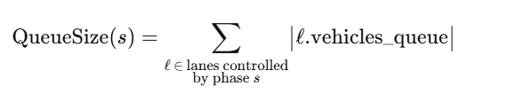
Implementation Details:
- The method get_max_vehicle_count_state_index() iterates through all candidate phases of size states_size.
- For each phase, it exercises each TrafficLight in available_states[state_index], gets the sum of the lengths of its vehicles_queue across all its lanes, and maintains a maximum..
- The method returns the index of the obtained maximum total queue length in O(S×L), where S is the number of phases and L is the average lanes per phase.

Our algorithm that we want to compare to real world traffic light algorithms:

GreenWave ( Min Energy)
Overview:A predictive approach that considers the energy expended to bring vehicles to a certain velocity from a stop, and chooses the phase that minimizes the expected energy cost.

Selection Rule:
next = get_min_expected_filter_state_index("energy")

For each candidate phase s, the method:
- Identifies vehicles that will be able to pass the Junction without stopping. (vehicles 3-17 or 7-17 seconds from the stop line, depending on whether the current lane’s traffic light is green or not).
- For each of these vehicles v, we compute the expected energy cost to decelerate and re-accelerate stylishly and smoothly at the most permissive velocity at the light, even if just momentarily.
- Accumulates these per-vehicle costs into a total E(s). The phase with the lowest E(s) is selected. Complexity increases with a growing count of vehicles in relevant timespans, but remains tractable for typical urban volumes.

GreenWave (Min Pollution)
Overview: Mirrors the Min Energy variant but targets emissions instead of fuel use.

Selection Rule:
next = get_min_expected_filter_state_index("pollution")

All steps are the same as Min Energy, except that each vehicle's get_pollution_to_velocity(…) replaces their energy calculation. This allows the system to continue trading delay versus environmental impact.

Research process

As part of Phase B, we first endeavored to ground our simulator in reasonable vehicle and emissions models by modelling the kinematic principles of acceleration, deceleration, and idling alongside fuel-consumption and pollutant-emission equations to provide realistic energy and air-quality estimates. Simultaneously, we learned about two traditional traffic-control schemes: fixed-timing cycle ("time-in-cycle") for its simplicity and predictability, and adaptive queue-proportional control for its real-time responsiveness to congestion as benchmarks. Finally, we reviewed traffic-engineering standards and intersection design specifications that informed our JSON map importer and ensured signal placements, phase groupings, and lane configurations represented the realities of roadway geometries. This combined research informed our simulation's vehicle dynamics, algorithm parameters, and map-generation logic.

In Phase B we faced both analysis and engineering challenges, and arrived at the following solutions:

First, we could not find a ready-made road-and-vehicle simulator suitable for the project, so we created our own engine from scratch. Analytically, we needed to define the data models (Junction, Direction, Lane, Vehicle) and choose a graph structure that allowed us to traverse intersections and compute vehicle paths efficiently. Technically, we needed to implement a force-directed layout for positioning the intersections on the screen, and a custom “knapsack” routine to produce legal traffic-light phase combinations at each junction.

Second, the automatic map and signal mapping proved nontrivial: real networks can have irregular lane counts and turning rules. We solved this by creating a two-pass json loader, first building all OUT-lanes, and then matching the IN-lanes by index guaranteeing that each turn lane found its proper partner, and automating traffic-light grouping right from the map data.

Finally, real‑time, multithreaded control taxed our CPU and threatened race conditions

Results
All the following results are based on runs done on the same map, which consists of 5 junctions and 9 roads connecting them.

Energy Consumption (30 Vehicles)
In table we report total energy use under three control schemes for a scenario with 30 vehicles. The “Δ vs Adaptive” column shows the percent change in total energy use relative to the Adaptive (queue‑count) baseline.

Algorithm | Energy (Megajoule) | Δ vs Adaptive
Fixed‑Timing Cycle | 45.42 | +13.1%
Adaptive (Queue‑Count) | 40.19
GreenWave (Energy) | 33.28 | –17.2%

Total energy consumption. GreenWave (Energy) cuts energy by 17.2% versus Adaptive and by 26.7% versus Fixed‑Timing.

CO₂ emissions (30 vehicles)
To test scalability, we executed both Adaptive and our GreenWave (Pollution) algorithm at four separate traffic loads. Table shows the energy and emissions savings GreenWave was able to achieve over Adaptive in each case.

Vehicles | Adaptive Energy(MJ) | GreenWave Energy(MJ) | Energy Savings(%) | Adaptive CO₂(kg) | GreenWave CO₂(kg) | CO₂ Savings(%)
6 | 8.02 | 5.79 | 27.8 | 1.10 | 0.5 | 54.6
15 | 20.34 | 18.06 | 11.2 | 1.90 | 1.40 | 26.3
30 | 48.94 | 39.93 | 18.4 | 5.80 | 3.70 | 36.2
150 | 235.19 | 200.79 | 14.8 | 25.60 | 18.70 | 27.0

All cases sustained energy savings above our 10% target which peaked under light traffic (27.8% at 6 vehicles) and settled between 15-18% at moderate to heavy loads.

Reductions in emissions were most dramatic at low traffic volumes (>50% CO₂ reduction at 6 vehicles), and still were over 25% in high-density traffic scenarios.

Conclusion

Interpreting these findings, we note:

The Baseline (30 vehicles):
GreenWave (Energy) saved 17.2% energy usage over the Adaptive algorithm.
GreenWave (Pollution) saved 36.2% CO₂ emissions over Adaptive.

Across volumes (6–150 vehicles):
Energy savings ranged from 11.2% to 27.8%, averaging ≈ 18.1%.
CO₂ reductions ranged from 26.3% to 54.6%, averaging ≈ 36.0%.

In every case, GreenWave exceeded our 10% target, proving both effectiveness and scalability for real-time traffic-light control.

User Documentation

User Guide

The GreenWave Traffic-Light Simulator is intended to allow users to load any JSON-defined road network and compare several signal-control strategies in real time. It was developed in Python 3.8+ with Pygame to support the interactive GUI. The software reads map files using the standard json module, spawns control threads in parallel using threading, and models vehicle dynamics with custom Junction, Direction, Lane, and Vehicle classes.

Main Screen
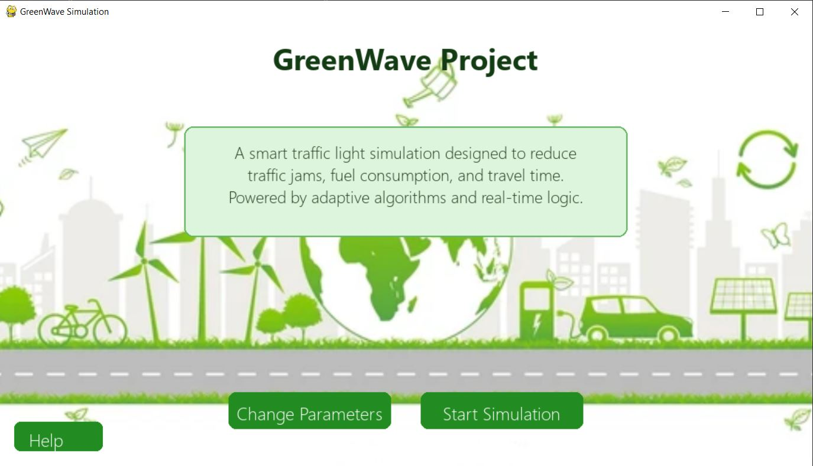

In the Main screen, we have 3 buttons and a description text box.
Each button opens a new screen that we will describe further.

Buttons:
- Help - opens help screen
- Change Parameters - opens settings screen
- Start simulation - opens simulation screen

Settings

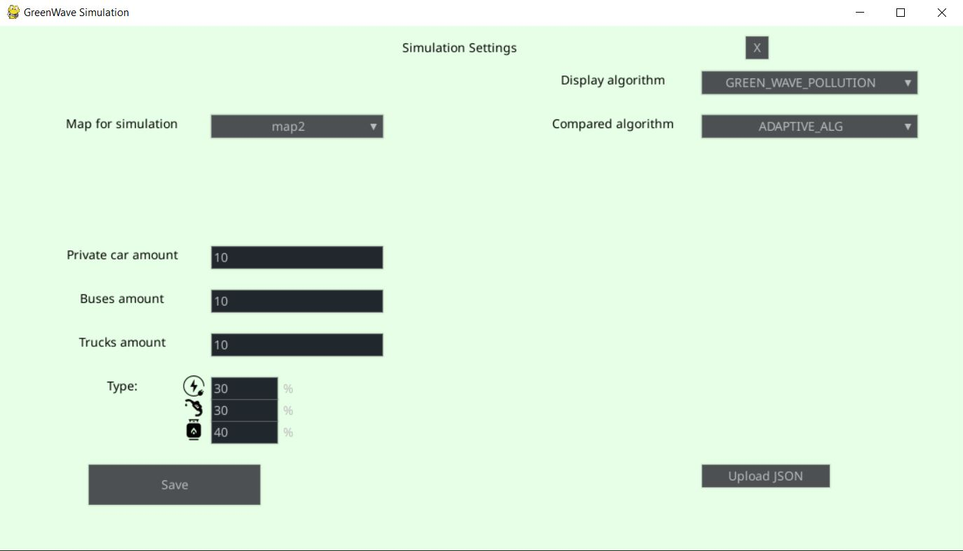

Using the Settings screen, the user can control the simulation parameters.
Also, advanced users can upload directly their settings file directly, which is very useful if you plan to interact with other software. In addition, they can add a valid and compatible map_n.json file to ‘maps/’ folder in order to run the simulation on a map of their own.

Settings parameters:
- Map for simulation -> can choose maps in JSON format from the folder maps in the project
- Display algorithm -> can choose from 4 algorithms that will be displayed in the simulation screen.
- Compared algorithm -> can choose from 4 algorithms that will be run in the background ( can’t be the same as display algorithm)
- Private car / Buses / Trucks amount -> number of vehicles that will be in both simulations.
- Type -> percentage of vehicles that will run on a specific fuel type, the sum of the percentages should be 100%.
- Upload JSON -> user can upload their own settings via a JSON file.
- Save -> will save all the settings into settings file

Simulation Screen

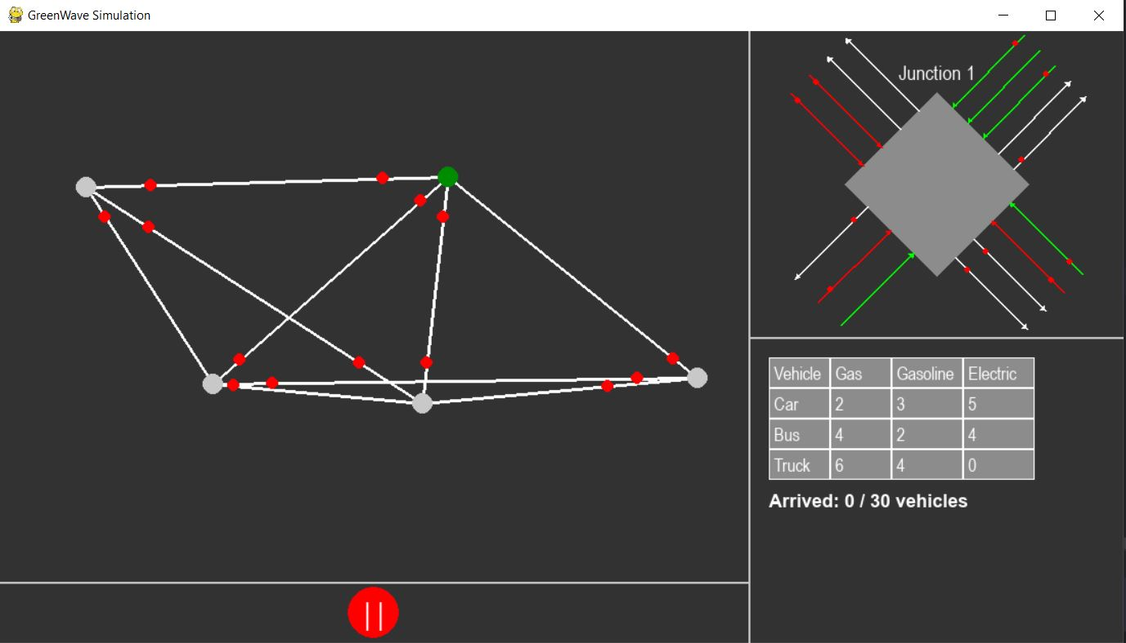

The Simulation Screen shows the displayed algorithm running on the map.
The user can track the number of vehicles and who has arrived, and click on a specific junction (gray dots on the graph) to view it in more detail.

Also, the user can pause the simulation and unpause it by clicking the red button at the bottom.

Operating Instructions

Running the software is simple, all you need is an IDE to open the code and just press the “run” icon. See the screenshot below.
Note: use pip install -r requirements.txt to install all requirements packages
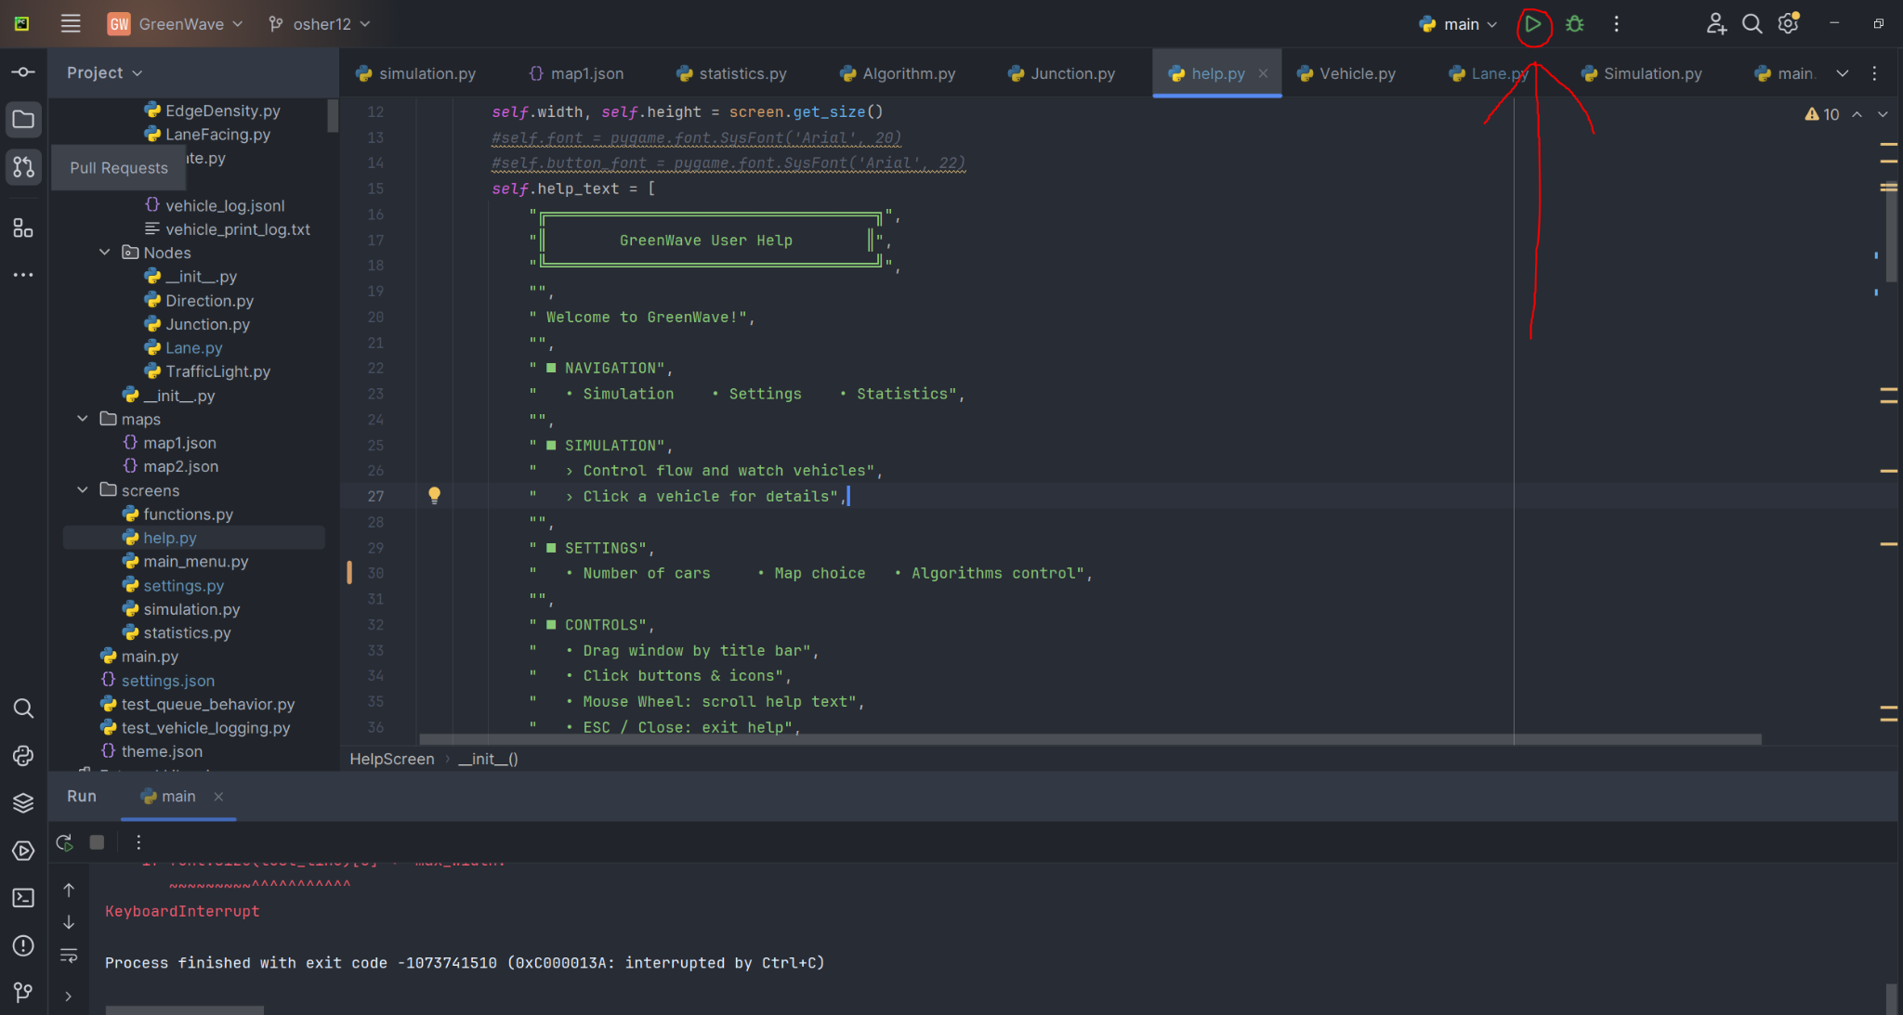

This will open the welcome screen, then to choose the simulation parameters we will go to settings screen.
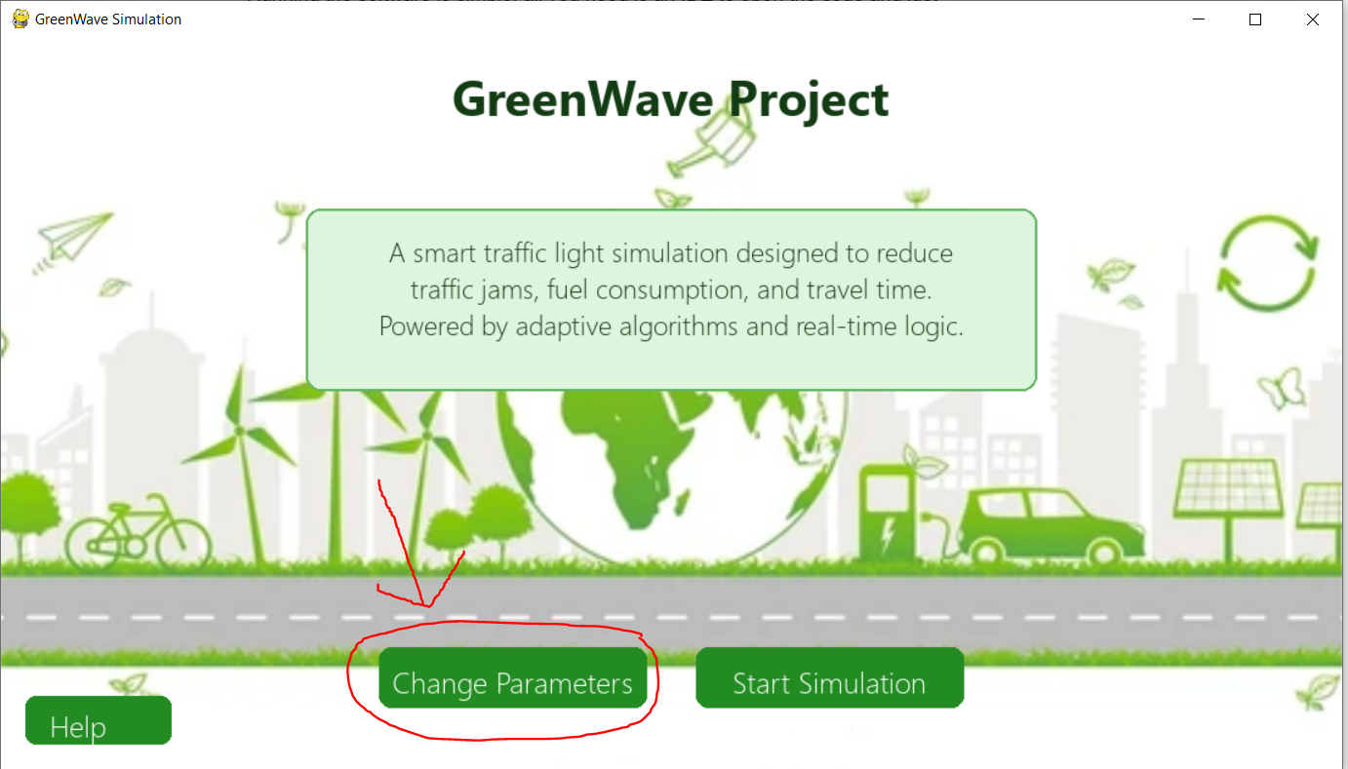

On the settings screen, we choose all the simulation parameters like: the number of vehicles, their type, and the algorithms that will be run.
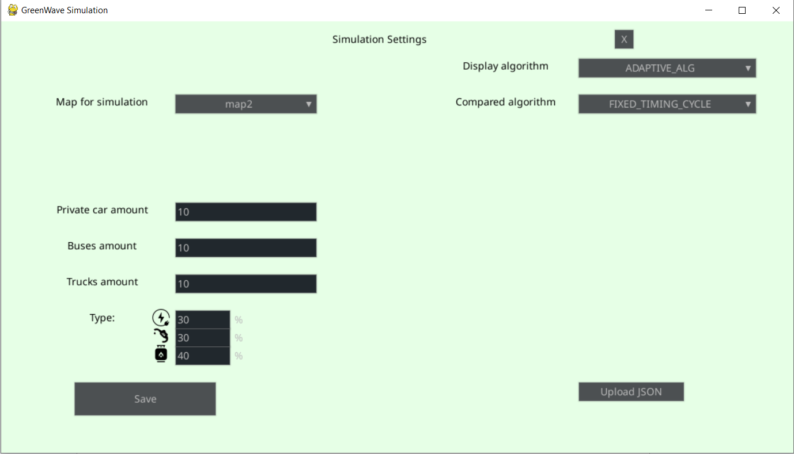

After we finish the parameters choosing phase, we press “Save”
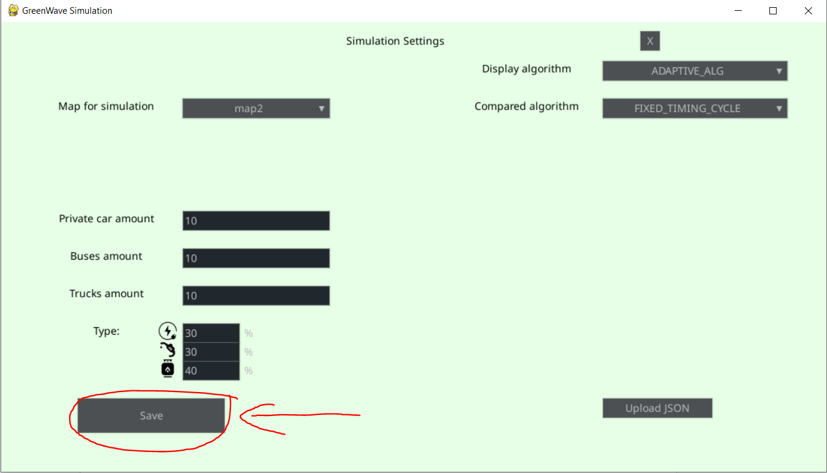

Then, to go back to the main menu, we need to press X
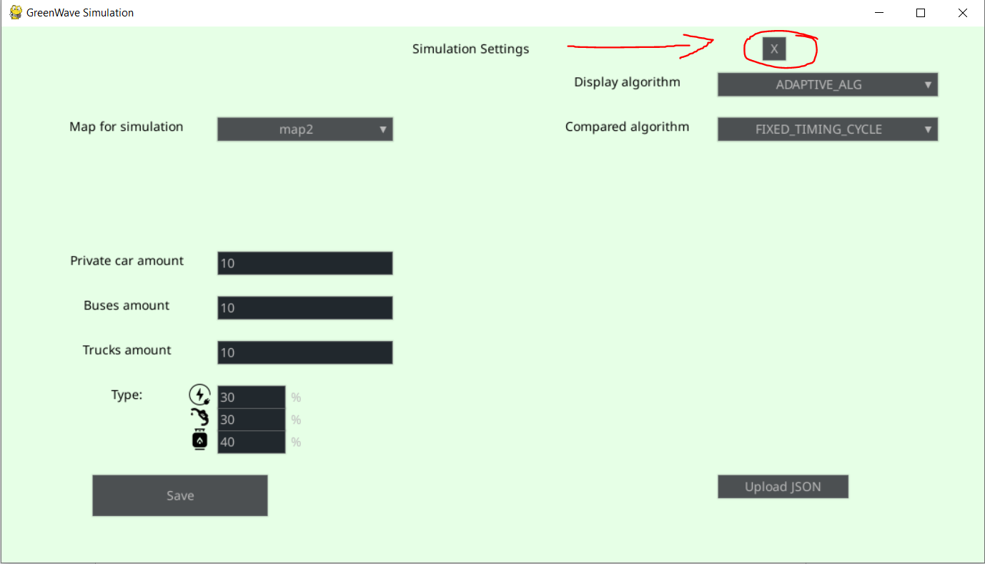
To run our simulation, we press the Start Simulation button.
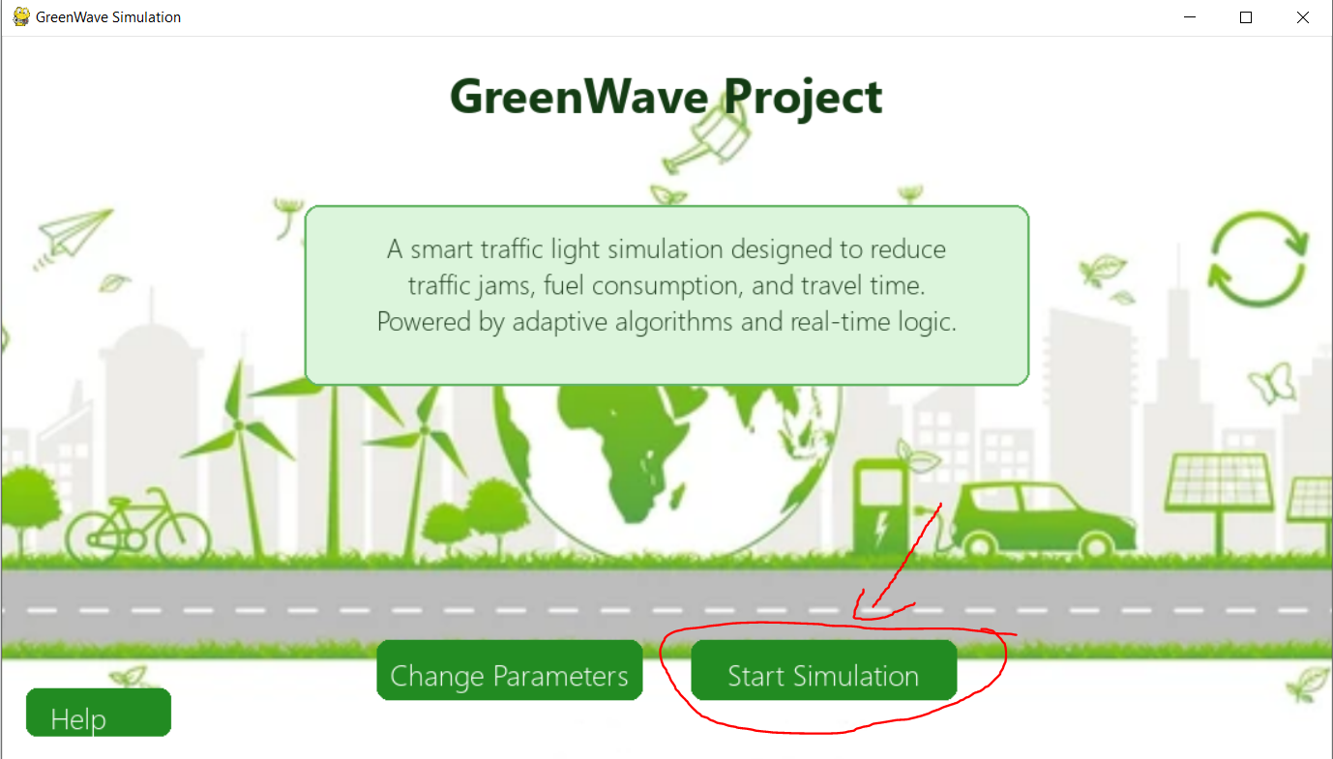

After we start the simulation, we will see the next screen, based on the settings:

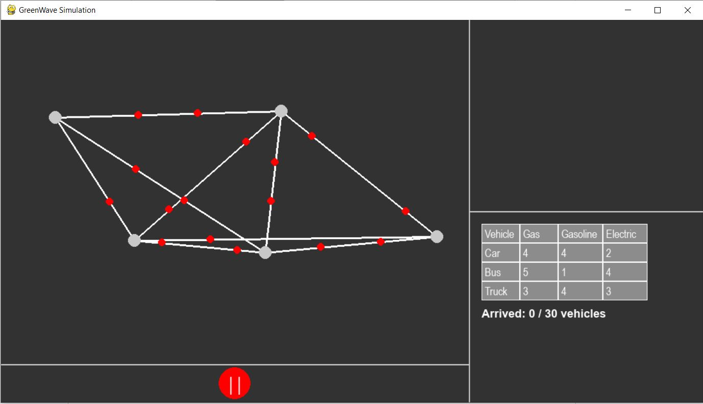

We can press on one of the junctions to show its details.
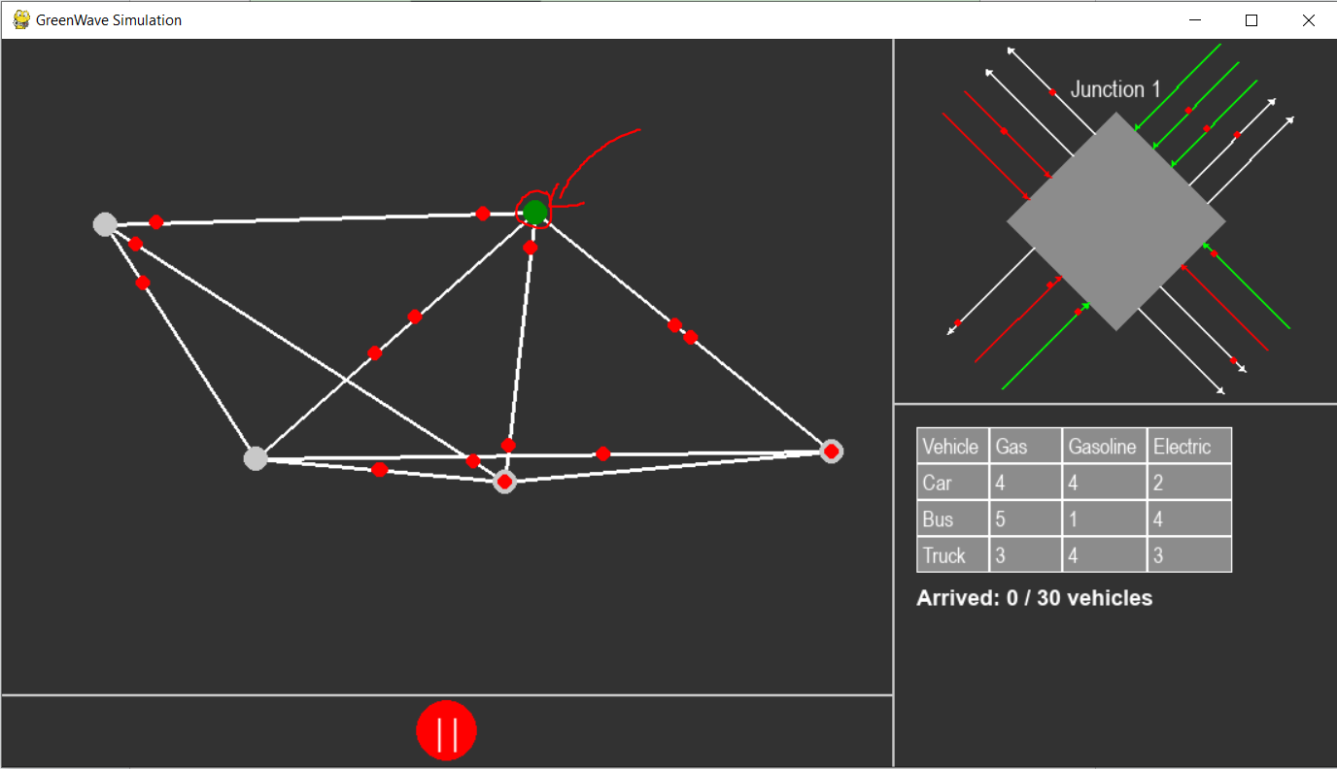

Also, we can pause and unpause the simulation by pressing the pause button
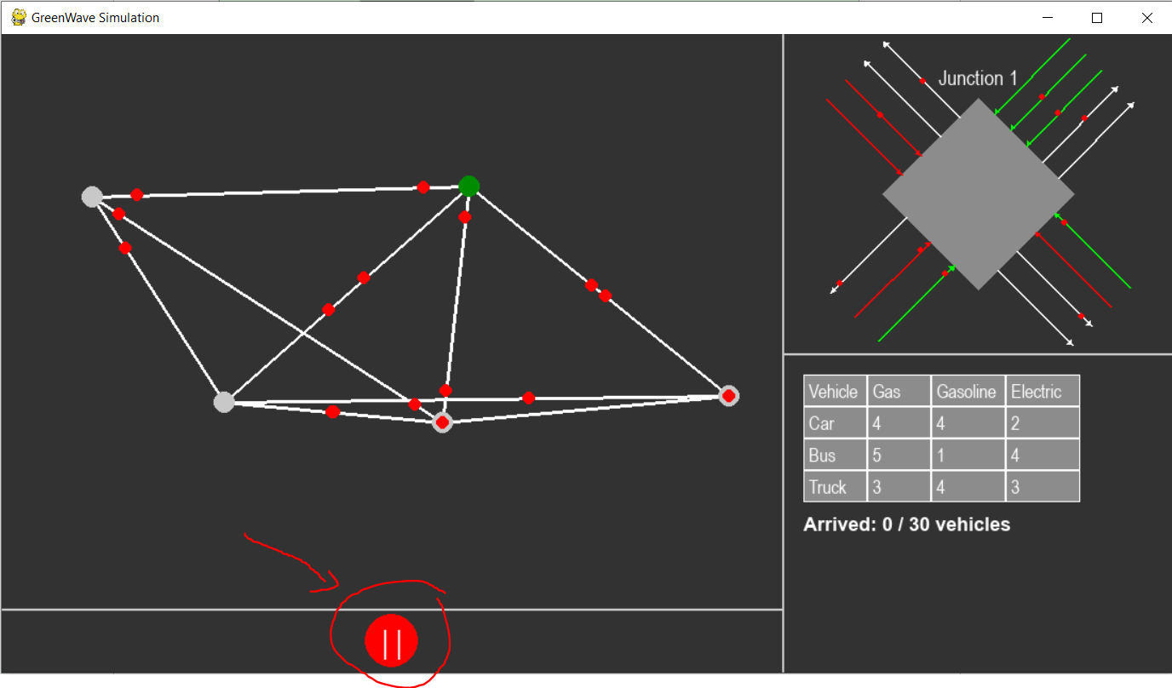
After the simulation ends and the loading screen will end, we will redirect to the statistics screen
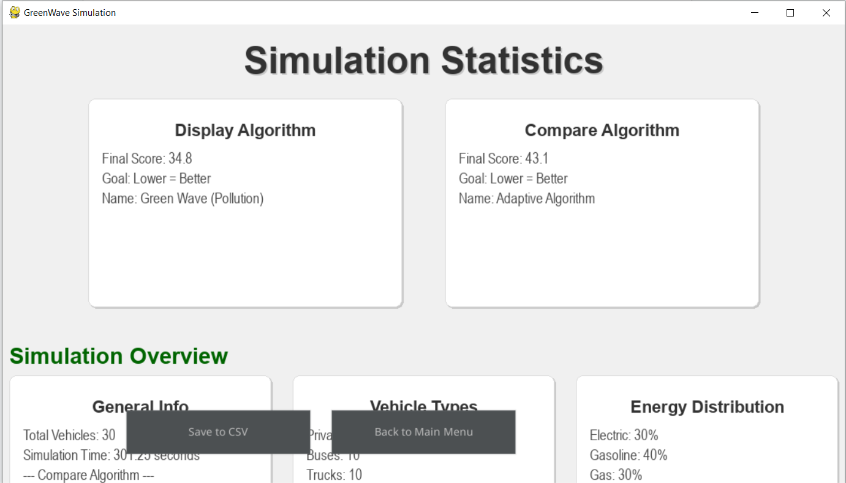

We can close the program or go back to the main menu by pressing “Back to main menu”

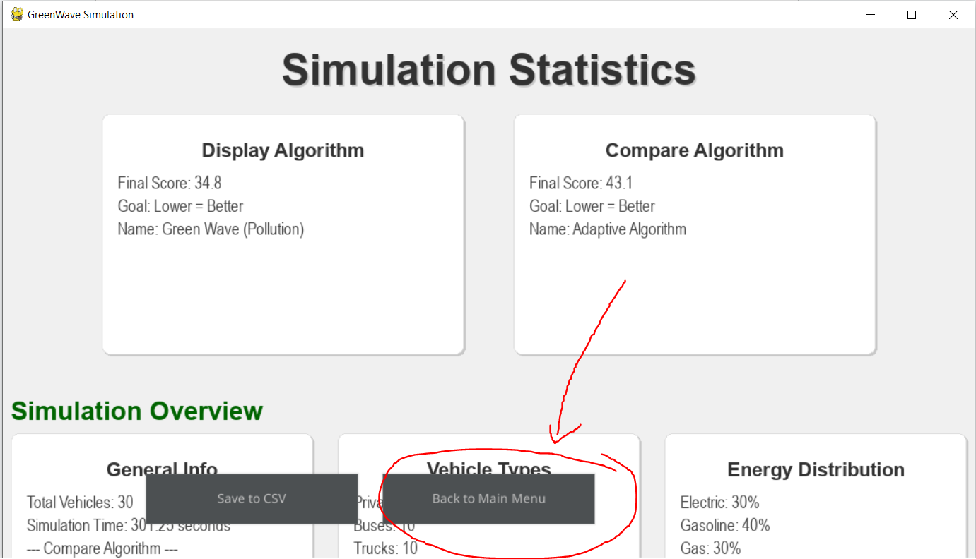

Or we can save all the data from this screen into CSV that will be in folder /results/..

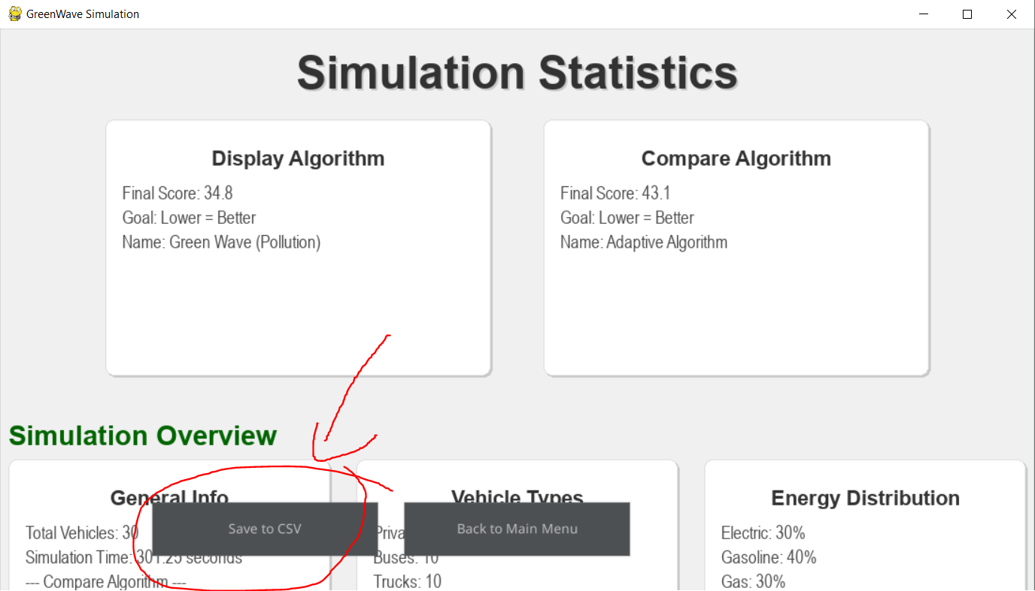

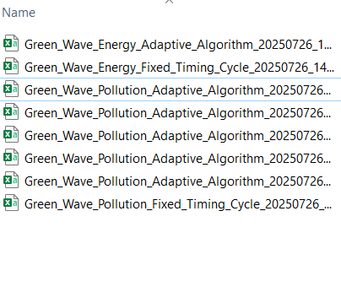

Maintenance Guide
Deployment & Maintenance Environment
To ensure continued use, updates, and improvements after project completion, the GreenWave simulator is designed to run on standard desktop hardware and relies only on widely‑available software components.
Hardware Requirements
- A multi‑core CPU (recommended ≥ 4 physical cores) to support concurrent algorithm threads.
- At least 8 GB of RAM for smooth GUI rendering and data buffering.
- No specialized GPU or server infrastructure is required - Pygame handles all graphics in software.
Software Prerequisites
- Python 3.8+
- Pip (for package installation)
- Operating system: Windows 10+, macOS 10.14+, or any modern Linux distribution with an X11/Wayland or Cocoa display.

Key Features
- Multi-Algorithm Support: Fixed timing, adaptive, green wave energy, and green wave pollution algorithms
- Real-time Simulation: Live traffic flow visualization with vehicle movement
- Energy & Pollution Tracking: Monitors vehicle energy consumption and emissions
- Configurable Maps: JSON-based map definitions for different traffic scenarios
- Statistics & Analytics: Comprehensive logging and performance metrics
- Modular Architecture: Extensible design for new algorithms and features
System Architecture: Core Components
1. Application Layer (`main.py`)
- Entry Point: Main application initialization and screen management
- UI Manager: Pygame GUI management with theme support
- Screen Router: Handles navigation between different application screens

2. Simulation Engine (`classes/Entities/`)
- Simulation.py: Core simulation controller and graph management
- Graph.py: Network representation with pathfinding capabilities
- Algorithm.py: Traffic light control algorithm implementations
- Point.py: Geometric coordinate system
3. Traffic Network Model (`classes/Nodes/`, `classes/Edges/`)
- Junction.py: Traffic intersection management with state machines
- Direction.py: Road direction in junction handling
- Lane.py: Individual lane management
- TrafficLight.py: Traffic signal control
- Road.py: Road segment definitions
- RoadLane.py: Lane-specific in road properties
4. Vehicle System (`classes/Entities/Vehicles/`)
- Vehicle.py: General vehicle class
5. User Interface (`screens/`)
- main_menu.py: Application main menu
- simulation.py: Primary simulation interface
- settings.py: Configuration management
- statistics.py: Performance analytics display
- help.py: User assistance
- functions.py: UI utility functions
6. Data Management
- Maps: JSON-based traffic network definitions (`maps/`)
- Settings: Configuration files (`settings.json`, `theme.json`)
- Logs: Simulation data and debugging information (`classes/logs/`)

